1. How a digital signal is creates?

**Digital signals** is the signal that its values and the time are discrete.

Continuous time → discrete time by sampling

Infinite digits → finite digits by quantization

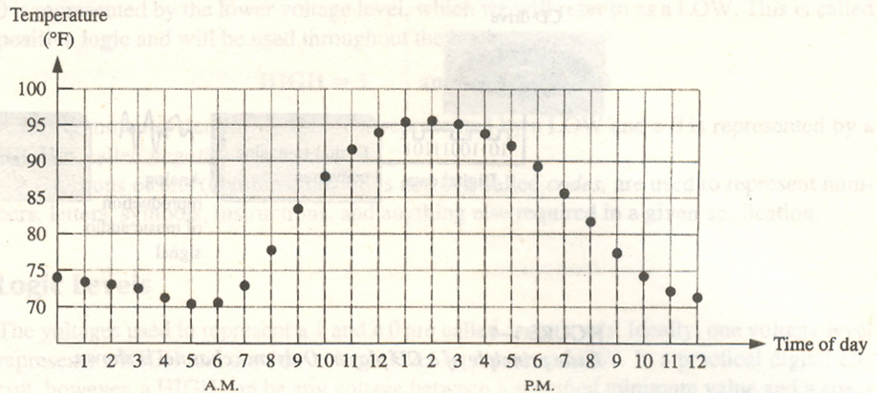

* **Binary digital signals**

**There are two digits in binary system, 0 and 1.**

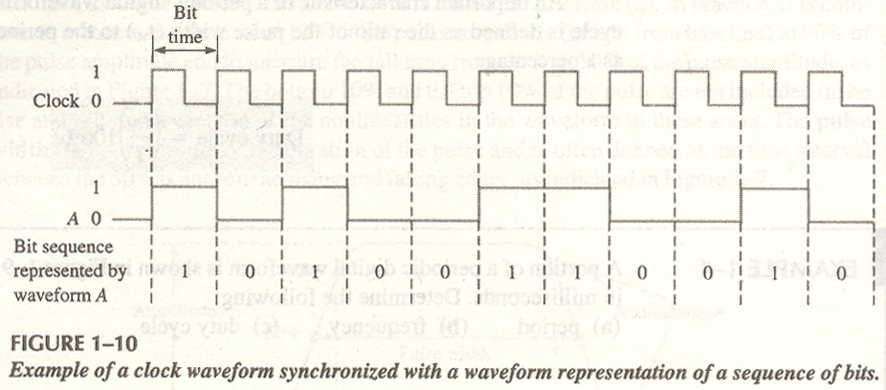

Digital circuits

A digital circuit is the circuit, which can process the digital signals.

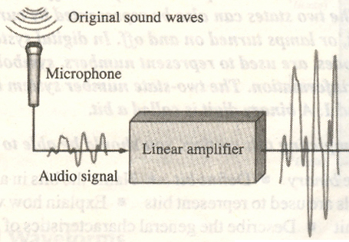

**Analog to digital converter**



**Encoder**

**Mp3**

**(wma)**

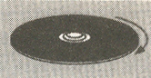

**CD rom**

**Memory**

2-.Why digital is better than analogue signal.

* Digital signals can convey information with greater noise immunity, because each information component (byte etc.) is determined by the presence or absence of a data bit (0 or one). Analog signals vary continuously and their value is affected by all levels of noise.
* Digital signals can be processed by digital circuit components, which are cheap and easily produced in many components on a single chip. Again, noise propagation through the demodulation system is minimized with digital techniques.
* Digital signals do not get corrupted by noise etc. You are sending a series of numbers that represent the signal of interest (i.e. audio, video etc.)
* Digital signals typically use less bandwidth. This is just another way to say you can cram more information (audio, video) into the same space.
* Digital can be encrypted so that only the intended receiver can decode it (like pay per view video, secure telephone etc.)
* Enables transmission of signals over a long distance.
* Transmission is at a higher rate and with a wider broadband width.
* It is more secure.
* It is also easier to translate human audio and video signals and other messages into machine language.
* There is minimal electromagnetic interference in digital technology.
* It enables multi-directional transmission simultaneously.

3.What makes a signal cover a long distance?

In free space the relation between the transmitted power (pt) and received power(pr),is

Pr ~ ( G/(f^2 × d ^ a )) × Pt

In which G is the transmitter antenna again

d is the distance between transmitter and the receiver;

f is carrier frequency;

a is the path loss exponent

from above equation, we realize that the greater frequency is the less power will be received at the reciever,which means that **high frequency signals can travel a small distance compares to lower frequency signals.**